1. Open <https://www.google.com/a/cpanel/railsforcharity.org>

2. Login as admin ( administrator in google app is [vinti@railsforcharity.org](mailto:vinti@railsforcharity.org) )

3. Go to Organizations and Users tab

4. Add a new user / email with password

**New Way:**

- Use firefox (a different browser than your regular one, to avoid login conflicts)

- Login to info@mobflair.com

- Goto <https://www.google.com/settings/dashboard>

- After login you should see something like below:

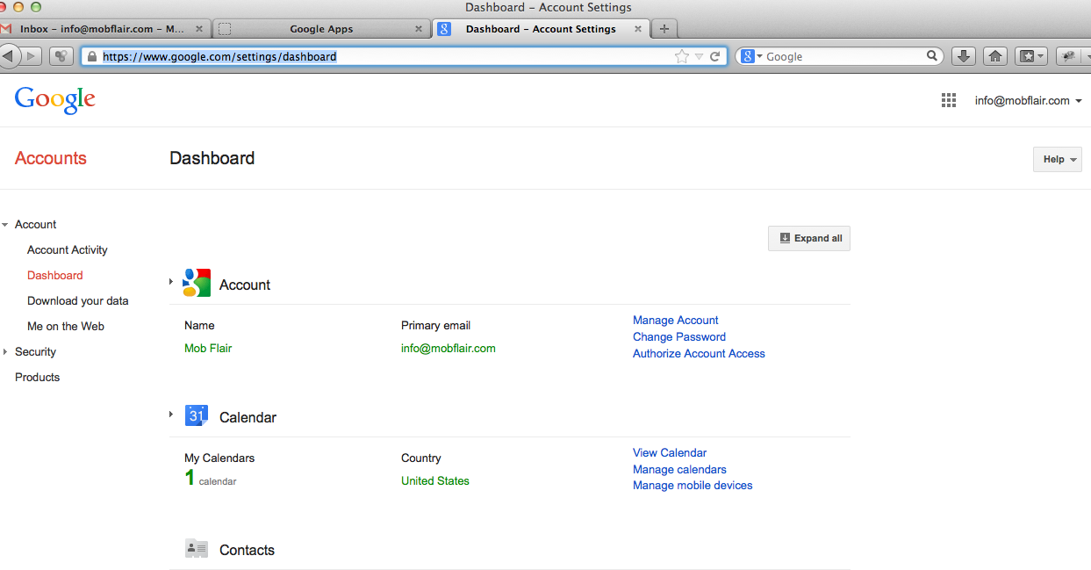

- Click Manage Account